Hardware Architecture of Multi-Layer ANN
Artificial Neural Network
Verified Through Real-Time Handwritten Digit Recognition

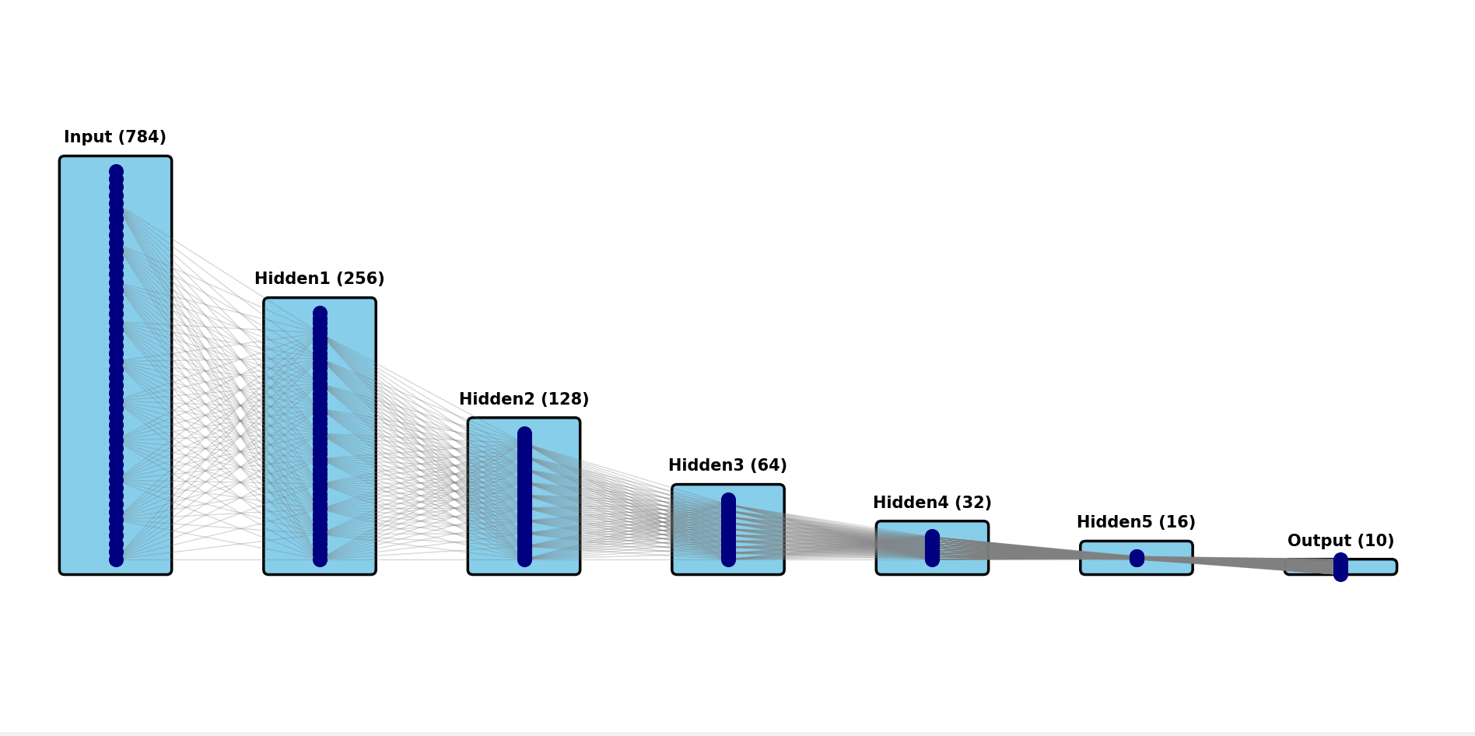
Input_Nuron_No:
28*28=784

5
Hidden1
256

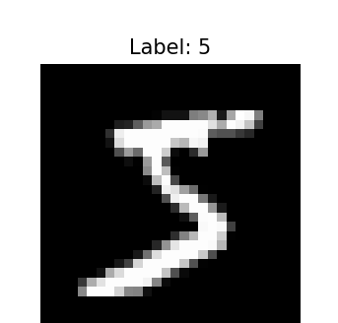
Hidden2
128
28*28
Hidden5
16

Output
10
Hidden4
32
Hidden3
64

Output_layer:
0.998
0.005
0.075
0.0012
0.008
0.076
0.0987
0.076
0.023
0.0067
Maximum probable
5
4
9
8
7
6
1
3
2
100

Basic Operational_Flow:
Input (784 neurons)
28×28 image pixels → input features
Hidden 4 (32 neurons)
Feature refinement + ReLU
Hidden 3 (64 neurons)
High-level feature learning + ReLU
Hidden 2 (128 neurons)
Dimensional reduction + ReLU
Hidden 1 (256 neurons)
Feature extraction + ReLU

Output (10 neurons)
Digit classification using Softmax
Hidden 5 (16 neurons)
Compact feature encoding + ReLU

Training and Deployment Workflow of a Hardware ANN for Handwritten Digit Recognition:

Key Points:

1.1 Hardware Limitation
The implemented hardware Artificial Neural Network (ANN) with the configuration 784 → 256 → 128 → 64 → 32 → 16 → 10 is strictly inference-only; it lacks the capability to learn or update weights autonomously.
All weights and biases must be pre-trained offline using software frameworks such as Python/TensorFlow and subsequently loaded into on-chip BRAM for real-time inference operations.

1.2 Software Training
An equivalent ANN model is developed in Python (TensorFlow/Keras) to perform offline training.
The model is trained on the MNIST dataset consisting of 60,000 handwritten digit images.
Each hidden layer employs the ReLU activation function, while the output layer uses Softmax for multi-class classification.
During training, forward and backward propagation are executed iteratively to optimize both weights and biases through gradient descent.

1.3 Weight and Bias Extraction
Upon completion of training, a total of 243,920 weights and 511 biases are extracted from the trained software model.
These parameters encapsulate the learned representation (knowledge) of the ANN and are stored for subsequent hardware deployment.

1.4 Hardware Conversion
All trained weights and biases are converted into a 16-bit fixed-point representation to ensure hardware compatibility with the target FPGA/ASIC architecture.
Input image pixels are normalized between –1.0 and +0.9999999 to maintain numerical stability during computation.
A Q6.10 fixed-point format is adopted, wherein 10 fractional bits are used to preserve precision in arithmetic operations.

1.5 Deployment
The quantized (fixed-point) weights and biases are loaded into hardware memory/registers (BRAM).
The hardware performs forward propagation only, utilizing the pre-trained parameters to classify unseen images.
The final output corresponds to the predicted digit, obtained from the Softmax output layer or by computing the argmax among the ten output neuron activations.

1.6 Result
The deployed hardware ANN successfully performs real-time handwritten digit classification, leveraging the pre-trained software weights for high inference accuracy and low-latency computation.
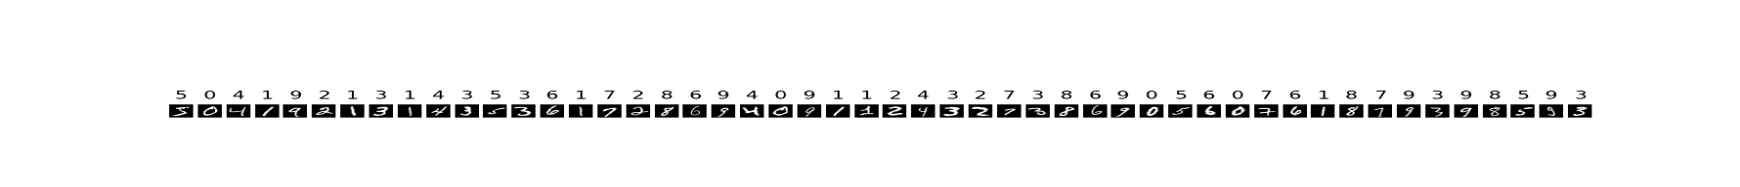

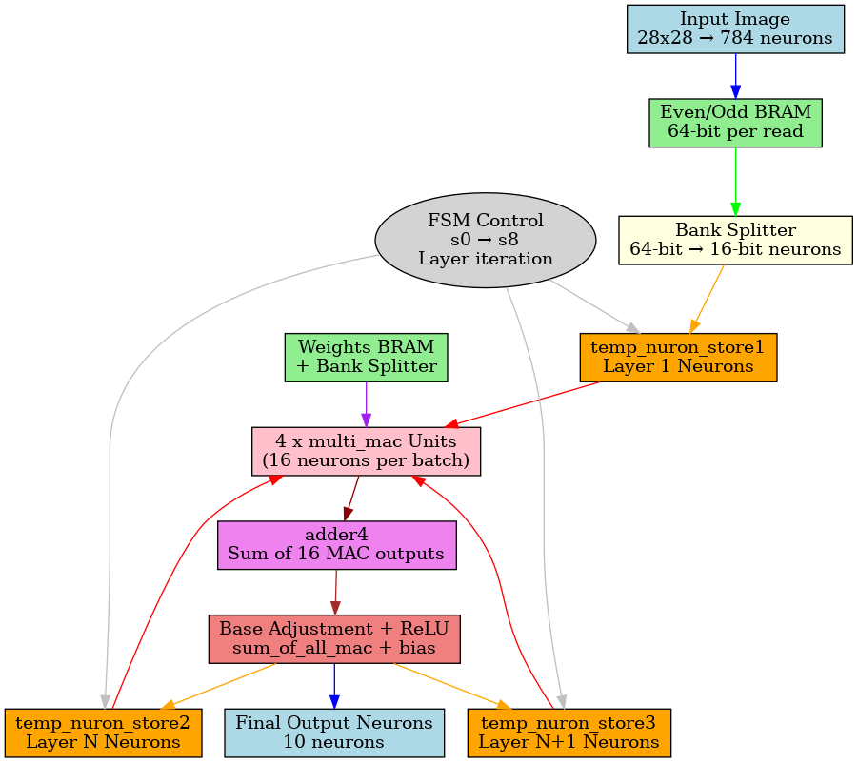

2.0 Overall Architectural Flow of the Hardware ANN Accelerator:

P1
P2
P3
.
.
.
P781
p782
P783
P784
1.
2.
3.
.
.
.
781
782
783
784
B1
B2
.
.
.
B505
B506
1.
2.
.
.
.
505.
506.
W1
W2
W3
.
.
.
.
W244383
W244384
1.
2.
3.
.
.
.
.
x
y
2.1 Memorey_Mapping_part:

28*28=784
Input_image
Baise_values
256+128+64+32+16+10=506
784*256+256*128+128*64+64*32+32*16+16*10
Total_Weight_no:=244384
0. | P4 | P5 | P6 | P7
1. | P12 | P13 | P14 | P15
. | . | . | . | .
. | . | . | . | .
97. | P780 | P781 | P782 | P783
. | . | . | . | .
100. | B4 | B5 | B6 | B7
101. | B12 | B13 | B14 | B15
163. | B508 | B509 | B510 | B511
. | . | . | . | .
170. | W4 | W5 | W6 | W7
171. | W12 | W13 | W14 | W15
172. | W20 | W21 | W22 | W23
. | . | . | . | .
. | . | . | . | .
. | . | . | . | .
. | . | . | . | .
. | . | . | . | .
A | We | Wf | Wg | Wh
0. | P0 | P1 | P2 | P3
1. | P8 | P9 | P10 | P11
. | . | . | . | .
. | . | . | . | .
97. | P786 | P778 | P780 | P781
. | . | . | . | .
100. | B0 | B1 | B2 | B3
101. | B8 | B9 | B10 | B11
163. | B504 | B505 | B506 | B507
. | . | . | . | .
170. | W0 | W1 | W2 | W3
171. | W8 | W9 | W10 | W11
172. | W16 | W17 | W18 | W19
. | . | . | . | .
. | . | . | . | .
. | . | . | . | .
. | . | . | . | .
. | . | . | . | .
A | Wa | Wb | Wc | Wd
Each location contains 64bit. _Per data contains 16 bit.Each location contains 4 data.
A=30717 :Wa=W244376 :Wh=W244383 :Total_Memorey=480KB
D1 D2 D3 D4 D5 D6 D7 D8 D9 D10 D11 D12 D13 D14 D15 D16

N1
rst
clk
rst
clk
ADDR_OA

ADDR_OB

ADDR_EB

ADDR_EA
Odd_BRAM_Block_DUAL_PO:

EVEN_BRAM_Block_DUAL_PO:RRT
image
Baise_value
Weights_value
Main_purpose:
Increas throughput: Per clock, I fetched 16 data at a time using two dual-port RAMs for parallel memory access and faster data throughput.

2.2Temporary_Resister_Maping:
Temp_Reg1(784/4=196 no: of location)
Used for only input image.Each location contain 64bit=4 data(16bit).
1. | P1 | P2 | P3 | P4
2. | . | . | . | .
. | . | . | . | .
. | . | . | . | .
. | . | . | . | .
196 | P781 | P782 | P783 | P784
Temp_Reg2(256/4=64 no: of location)
Result_Of Ist_hidden_layer_stored_Reg2.Reg3_data will used for next opeartion

stored
1. | T1 | T2 | T3 | T4
2. | . | . | . | .
3. | . | . | . | .
. | . | . | . | .
. | . | . | . | .
64. | T253 | T254 | T255 | T256
Temp_Reg3(128/4=32 no: location)
Result_Of 2nd_hidden_layer_stored_Reg2.Reg3_data will used for next opeartion

Stored
1. | t1 | t2 | t3 | t4
2. | . | . | . | .
. | . | . | . | .
. | . | . | . | .
. | . | . | . | .
32. | t125 | t126 | t127 | t128
Main_Purpose:

Reuse-Based Temporary Register Optimization
The temporary register reuse technique plays a pivotal role in enabling the implementation of an arbitrary number of hidden layers efficiently, while significantly minimizing on-chip memory utilization and facilitating seamless data transfer between consecutive layers.
Each temporary register location is 64 bits wide, capable of storing four 16-bit neuron values.
In the initial design, 16 neuron values were fetched per clock cycle using index values K, K+1, …, K+15.
After architectural optimization, this access pattern was refined to K, K+1, K+2, K+3, thereby reducing Look-Up Table (LUT) utilization by nearly 35% without compromising computational throughput.
Following the completion of computations for a given hidden layer, the design alternates between temp_reg1 and temp_reg2 instead of continuously reusing a single register.
This ping-pong buffering approach allows efficient reuse of storage resources, thereby further minimizing LUT usage and simplifying control logic.
Additionally, the data aggregation mechanism was optimized by combining 64-bit data accumulation across four clock cycles into a single write operation to the temporary register, replacing four separate write transactions.
This modification significantly reduced logic complexity, improved data path efficiency, and enhanced overall hardware performance.
Through the integration of these architectural optimizations, LUT utilization was reduced from approximately 70K to 19K, demonstrating a highly resource-efficient and scalable hardware implementation strategy for the proposed ANN design.
.

2.3Parallel_Pipelineing_MAC_operation:
DATA
BUS
A1w1+a2w2+a3w3+a4w4
=p1
Latency=2clk
2_stage_pip:

Temp_Accumuletor

Adder
A5w5+a6w6+a7w7+a8w8
=p2
Latency=2clk
2_stage_pip:

A9w9+a10w10+a11w11+a12w12
=p3
Latency=2clk
2_stage_pip:

Initial latency=3.After 3clk ,x1w1+…x16w16 operation will be happened within in 1 clk

A13w13+a14w14+a15w15+a16w16
=p4
Latency=2clk
2_stage_pip:

h

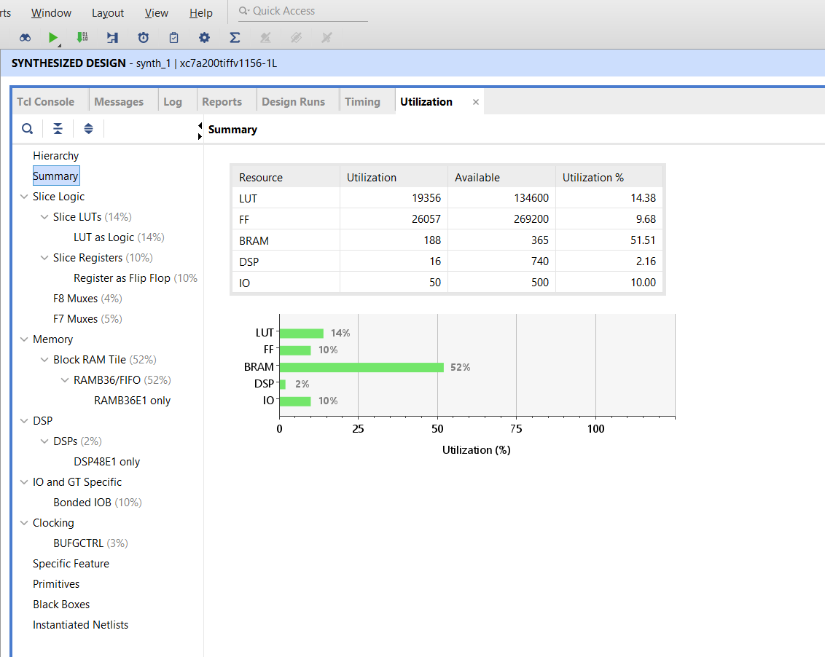
Post-Synthesis Hardware Resource Report

Trainable_Files:
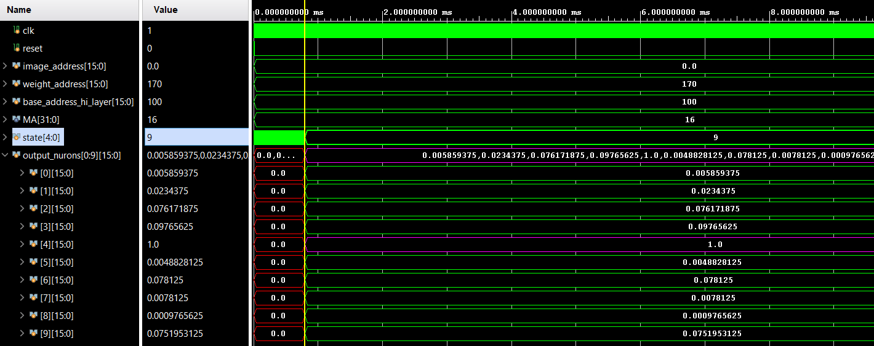
Simulation Result:
5 NO index has maximum probability of digit classification.So this model Successively able to recognize the Handwritten digit(0--9)

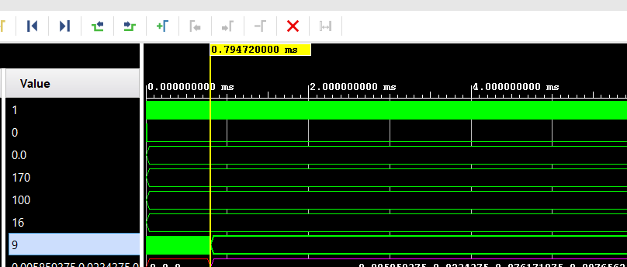

Completion time: 0.794msec

